**Data Compression**

Data compression refers to the process of reducing the size of data while maintaining its essential information. This is a crucial concept in computing because it optimizes storage space and improves transmission speed over networks.

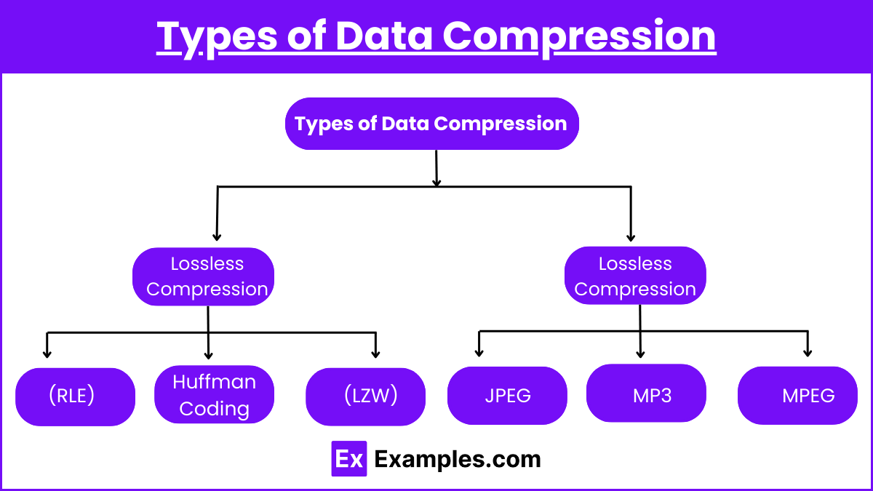

Data Compression refers to the process of reducing the size of data to save storage space or transmission time. This is critical in computer systems, especially when dealing with large files or streaming media.

### Lossless Compression

* **Definition**: In lossless compression, no data is lost during the compression process. Lossless compression refers to a method of data compression where the original data can be perfectly reconstructed from the compressed data. This is particularly useful in cases where exact data recovery is crucial, such as in text files, software, or sensitive data.
* **Common Algorithms**:
  + **Run-Length Encoding (RLE)**: This algorithm compresses data by replacing consecutive identical values with a single value followed by a count. It's commonly used for simple images.
  + **Huffman Coding**: This algorithm uses variable-length codes to represent data. More frequent data items are assigned shorter codes, while less frequent ones get longer codes.
  + **Lempel-Ziv-Welch (LZW)**: This is a dictionary-based method that replaces repeated sequences of data with shorter codes. It’s used in formats like GIF and PNG.
* **Use Cases**:
  + File formats such as PNG, ZIP, and GIF.
  + Applications where data integrity is critical, like text documents, program files, and databases.

### Lossy Compression

* **Definition**: Lossy compression is a data compression technique where some of the original data is permanently discarded to reduce file size. It’s typically used in applications where perfect accuracy is not necessary, and some level of quality degradation is acceptable, such as in images, audio, and video files. The key idea behind lossy compression is that it removes less important or redundant data that is less noticeable to human perception.
* **Common Algorithms**:
  + **JPEG**: Used for image compression, where it reduces file size by discarding certain color details that are less noticeable to human vision.
  + **MP3**: Used for audio compression, where it eliminates frequencies inaudible to most humans.
  + **MPEG**: Used for video compression by removing redundant visual and audio data between frames.
* **Use Cases**:
  + Media files like images (JPEG), audio (MP3), and video (MPEG).
  + Applications where some loss in data quality is acceptable to save significant storage space.

### Benefits of Data Compression

* **Reduced Storage Requirements**: Compressed data takes up less space, allowing more data to be stored on the same medium.
* **Faster Data Transmission**: Smaller file sizes reduce the time required to send data over networks, improving bandwidth efficiency.
* **Cost Savings**: With reduced storage and transmission needs, costs for data management, bandwidth, and hardware are lowered.
* **Improved Performance**: By compressing data, applications that require frequent read/write operations can perform faster due to reduced I/O operations on smaller files.
* **Enhanced User Experience**: Compressed files, especially in media streaming or web content, load faster, leading to smoother user interactions and fewer buffering issues.
* **Decreased Network Congestion**: Compression reduces the amount of data sent over networks, easing the load on network infrastructure and improving overall traffic flow, particularly in high-demand environments.

### Trade-offs in Compression

* **Lossless vs. Lossy**: While lossless compression ensures no data loss, the degree of compression is typically less than with lossy techniques. Lossy methods can achieve much higher compression rates but sacrifice some data accuracy, which may affect the quality of the file (e.g., lower image resolution or sound quality).
* **Speed vs. Accuracy**: Some compression methods are faster but may offer less effective compression, while others might be slower but more efficient in reducing file size.

### Compression in Real-World Applications

* **Web Optimization**: Lossy image compression (JPEG) is crucial for web page speed optimization, where smaller image sizes lead to faster page loading times.
* **Multimedia**: Videos and music often use lossy compression for streaming services to reduce file size and improve download speeds.
* **Archiving**: Lossless formats (ZIP, PNG) are often used for data archival, where preserving the original data is important.
* **File Sharing and Cloud Storage**: Services like Google Drive, Dropbox, and email attachments utilize compression to reduce file sizes, allowing faster uploads/downloads and more efficient storage usage.
* **Gaming**: Video games often use compression techniques for textures, audio, and video files to minimize download sizes and load times without compromising the gameplay experience.

### Example 1: JPEG Image Compression

* JPEG (Joint Photographic Experts Group) is a widely used **lossy compression technique for images.**
* It reduces the file size by discarding certain color and brightness details that are less noticeable to the human eye.
* High-quality images can be stored or transmitted using significantly less space, making it ideal for websites and digital photography, where image quality is balanced against file size.

### Example 2: MP3 Audio Compression

* MP3 (MPEG Audio Layer III) is a popular **lossy audio compression format.**
* It reduces the size of audio files by removing frequencies that are beyond human hearing or less perceptible in a given context.
* MP3 files are widely used for music and audio storage, especially in streaming services, as they provide a manageable file size while maintaining acceptable sound quality.

### Example 3: PNG Image Compression

* PNG (Portable Network Graphics) is a format that **uses lossless compression.**
* It employs techniques such as Run-Length Encoding (RLE) and Lempel-Ziv-Welch (LZW) to reduce file size without losing any image data.
* PNG is especially useful for images that require transparency and sharp edges, such as logos and icons, where data integrity must be preserved.

### Example 4: ZIP File Compression

* ZIP is a common **lossless** file compression format used to bundle and compress multiple files or folders into a single archive.
* It uses various compression algorithms, like DEFLATE, to reduce file size without losing any data.
* ZIP files are often used for sharing documents or software, as they allow the recipient to reconstruct the exact original data after decompression.

### Example 5: MPEG Video Compression

* MPEG (Moving Picture Experts Group) compression is a **lossy** technique widely used for reducing the size of video files.
* It compresses video by eliminating redundant information across frames and reducing less noticeable details in the visual and audio streams.
* This makes MPEG formats ideal for streaming services and online video platforms, where large video files need to be delivered efficiently.

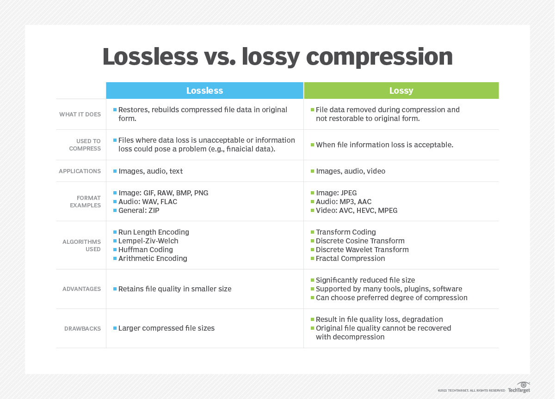

## What is image compression?

Image compression is a process applied to a graphics file to minimize its size in [bytes](https://www.techtarget.com/searchstorage/definition/byte) without degrading [image](https://www.techtarget.com/whatis/definition/image) quality below an acceptable threshold. By reducing the file size, more images can be stored in a given amount of disk or memory space. The image also requires less [bandwidth](https://www.techtarget.com/searchnetworking/definition/bandwidth) when being transmitted over the internet or downloaded from a webpage, reducing network congestion and speeding up content delivery.

| Image formats | Image compression type | Pros | Cons | Suitable for |
| --- | --- | --- | --- | --- |
| JPEG | Lossy | High-compression capability  Low memory requirements  Quick loading time | Narrow compatibility.  Doesn't support transparencies or animations | Websites  Print |
| PNG | Lossless | Lossless compressions  Supports transparency and the alpha channel  Full-color range | Doesn't fit for printing  Large image file size  Lacks software support | Websites |
| GIF | Lossy | Suitable for simple animations | Limited to 256 colors Web only | Websites  Animated moving graphics |
| TIFF | Lossless | High image quality  Transparencies and layers | Not compatible with many browsers  Large image file size | High-resolution images  Artwork  Print |
| RAW | Lossless | Provides most image data  Flexible when it comes to editing  High image quality | Not homogenized for all camera products  Hard to share or duplicate  Large image file size  Needs special software to be edited | Film photography  Professional photography  Pint |
| BMP | Lossless | Works perfectly with Windows software  Large color spectrum  Simply structured | Large image file size | A perfect pick for storing and displaying high-quality digital images |

## **Best tools for image compression**

**Are Tinyimg & JPEG OTIMIZER**